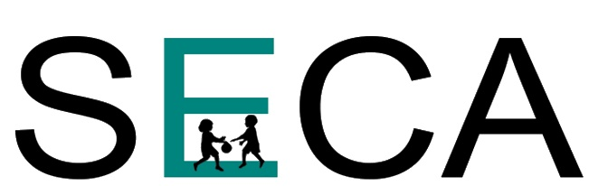
Presenter Agreement
74th Annual Conference
Chattanooga, TN
March 2-4, 2023

As the submitting presenter, I agree to and understand the following if my proposal is accepted.

- The presenter agrees to share this agreement with any co-presenters listed on your proposal.
- The presenter understands that all presenters are required to register for the SECA conference. The following discounts apply for up two (2) presenters.
If your proposal is received no later than:
  - July 2nd you receive 75% off of the 3 day general registration fee.
  - August 13th you receive 40% off of the 3 day general registration fee.
- The presenter agrees to notify us immediately if an emergency requires cancellation.

- While it is permissible to teach about topics related to the presenter’s practice or products, it should be done in an unbiased manner, with absolutely no direct sales or pricing of products or services. If you are exhibiting at SECA you may direct attendees to your exhibit booth.

- The presenter agrees to start and finish in the time frame assigned, even if the topic has not been fully covered by the scheduled end of the session.

- The presenter agrees to communicate the need for specific room layouts at the time of proposal submission. Due to time constraints complete room resets may not be possible.

- The presenter agrees not to rearrange the room layout prior to the session. The presenter is not authorized to order tables or chairs from the conference venue.

- Educational materials and copying of handouts is the responsibility of the presenter. If your proposal is approved you will be provided an approximate room capacity when scheduled to help you plan for attendees.

- There will be no audio or video equipment provided for your presentation. This includes projectors, laptops, extension cords, mac connectors or screens.

